# GREP FILTER

This is the directory and file and the data in the files I am using

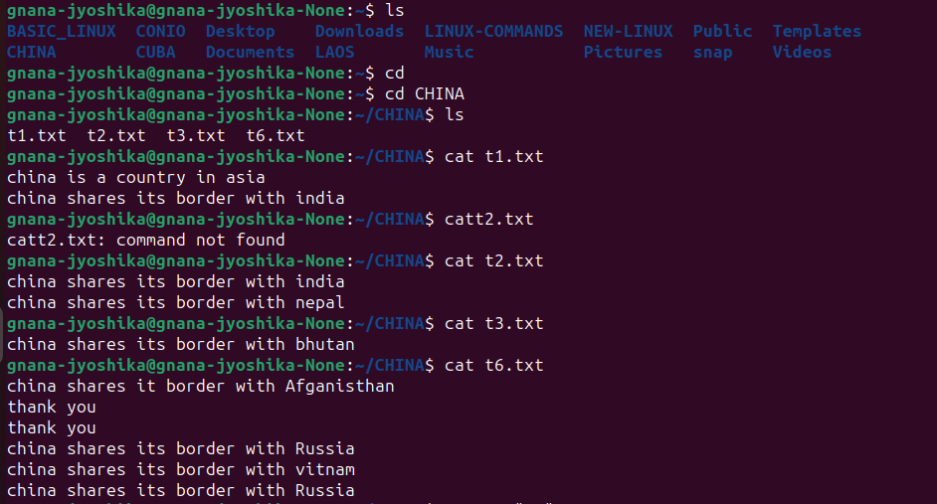

1. c : grep-c pattern file - displays number of matching lines with the pattern.



1. h : grep-h pattern file - displays all the matching lines with the pattern.



1. l : grep-l pattern file - displays all the file names in which the pattern

matches.

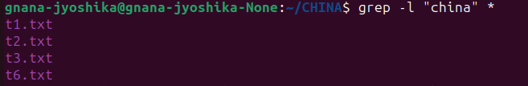

1. n : grep-n pattern file - display all the matching with the line number of it

(not the serial numbers of the at the time of displaying).

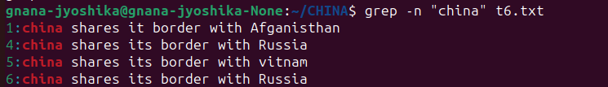

1. v : grep-v pattern file - displays all the non-matching lines.



1. o : grep-o pattern file - displays only the matching pattern, how many ever times its matching that many times it is going to display the pattern.



1. e : grep-e pattern file - this command can be used to search multiple patterns at the same time. It displays all the lines matching the pattern



1. ^ : grep ^pattern file - this displays all the lines which starts with the given pattern.



1. $ : grep pattern$ file - it displays the lines ending with the given pattern.



1. i : grep-i pattern file - this is a case in sensitive search.

